**Accurx**

Accurx is replacing eConsult on the 13th March 2024. eConsult will no longer be available from 5pm the 12th March 2024 and you will be able to submit any online request via Accurx via our practice website **https://florey.accurx.com/p/G85721** or via [NHS app](https://www.nhs.uk/nhs-app/) or via [NHS website](https://www.nhsapp.service.nhs.uk/login)

**Please read the information below.**

Accurx is the new way to contact your practice online which helps you access the help and advice you need at the right time, in the right place, with the right person.

If you need help with a non-urgent medical or admin request, you can now contact us online via our website **https://florey.accurx.com/p/G85721** or via [NHS app](https://www.nhs.uk/nhs-app/) or via [NHS website](https://www.nhsapp.service.nhs.uk/login). We will aim to deal with your request within a day (medical issues) and next day (urgent admin). Click to see demonstration [Patients point of view - submitting a reques](https://gbr01.safelinks.protection.outlook.com/?url=https%3A%2F%2Fwww.youtube.com%2Fwatch%3Fv%3D4EDwg-feeUI%26t%3D113s&data=05%7C02%7Cleonor.mondata3%40nhs.net%7C1944e446b9514e86529308dc346b0884%7C37c354b285b047f5b22207b48d774ee3%7C0%7C0%7C638442881504110434%7CUnknown%7CTWFpbGZsb3d8eyJWIjoiMC4wLjAwMDAiLCJQIjoiV2luMzIiLCJBTiI6Ik1haWwiLCJXVCI6Mn0%3D%7C0%7C%7C%7C&sdata=OAHq8xRAJ05afZPLR%2FVtYUzsXe9nbjwnPJ%2BQLhHY%2BU0%3D&reserved=0)t

If you have not yet registered with NHS app, please do so aside from contacting our practice, you would be also able to order repeat prescriptions, view your GP (General Practice) records and test results, quickly check symptoms, view, cancel or book GP appointments. Use this link [NHS app](https://www.nhs.uk/nhs-app/) or scan this QR code to download NHS app. Please click to see video demonstration [NHS App (youtube.com)](https://www.youtube.com/watch?v=vHk0AFXWdNA)

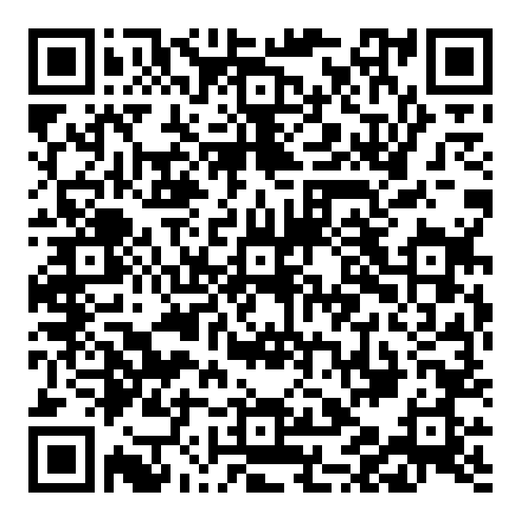

How it works

If you have a non-urgent healthcare concern or need to contact the Practice for any medical or admin reason, click on the online via our website **https://florey.accurx.com/p/G85721** or via [NHS app](https://www.nhs.uk/nhs-app/) or via [NHS website](https://www.nhsapp.service.nhs.uk/login). Fill out the online form, which will then be reviewed and processed by our healthcare professionals to decide the right care for you. We will respond to every online request within two days.

Please see link to a video below of how to submit an online request to our practice: [Patient Flash Demo: How to submit a medical request in Patient Triage (youtube.com)](https://www.youtube.com/watch?v=4EDwg-feeUI)

**How long is the form? Will it take me a long time?**

The form asks for your symptoms, the length of time these have been present or changed, how you would like the surgery to assist you, and how we can contact you once we have reviewed your request.

**I do not have a computer or smartphone. How can I fill out a form?**

A friend, relative, or carer can complete this form on your behalf. If this is not available to you, or you have communication needs which prevent this, then our reception staff may assist in completing this over the telephone for you. The form will still be completed, and your request will then go with the other patient requests we receive.

**Can a friend, relative, or carer do the form for me?**

Yes. On the form, there is a box where we ask you if the form is being completed by somebody else. Please note that we will only be able to reply to yourself regarding your care as the patient unless there is confirmed consent on your medical record.

**Here are some of the benefits of the new platform:**

* Easy and simple for patients to use.
* No lengthy triage questions.
* Allow patients to track their request.
* Patients can be sent a link to the most appropriate appointment.
* Options to self-refer to local healthcare services
* Accessible via NHS app and NHS website
* No need to create login if you do not want to

**Do I need to download anything or have a password?**

No. If you do not want to download anything, you do not need to download any application or have a username and password to use this form.

The forms are also accessible via [NHS app](https://www.nhs.uk/nhs-app/) or via [NHS website](https://www.nhsapp.service.nhs.uk/login) , if you have this set up.

**What times of day is the form available?**

The form will be available for completion from Monday to Friday. There is no cut off time at present but can alter in future depending on demand. This is to allow our clinical team to ensure we can review and triage appropriately each day. If you have a routine request, you will need to wait until next working day and complete the request.

If you are requiring urgent medical assistance or have a life-threatening emergency, you will still need to contact the emergency services or visit the hospital -[Find urgent and emergency care services - NHS (www.nhs.uk)](https://www.nhs.uk/nhs-services/urgent-and-emergency-care-services/find-urgent-and-emergency-care-services/)

What about my data?

Accurx is approved by NHS England to be used by the GP practices and the other systems involved in patient care. NHS England has a lengthy assurance process to make sure we meet the highest standards of safety and security. Your data is safe and is shared only with your GP Practice for the purposes of your direct care. Your data is stored and sent securely using industry best practices, and we only collect the data that is necessary to allow your GP Practice to provide you with care. For more information, please visit [The 301 East Street Surgery - Privacy Information](https://www.301eaststreetsurgery.co.uk/pages/Privacy-Information?Highlight=private+notice)