

East Street Surgery

**Harold Moody Health Centre,**

**60 Thurlow Street, London, SE17 2GN**

**Tel: 020 7703 4550**

**Email:** **[souccg.301eaststreetsurgery@nhs.net](mailto:souccg.301eaststreetsurgery@nhs.net) [www.301eaststreetsurgery.co.uk](http://www.301eaststreetsurgery.co.uk/)**

Details correct as at 12 June 2025

INFORMATION LEAFLET

# Opening hours

|  |  |  |
| --- | --- | --- |
|  | **Morning** | **Afternoon** |
| **Monday** | 8:00 – 13:00 | 13:00 – 18.30 |
| **Tuesday** | 8:00 – 13:00 | 13:00 – 18.30 |
| **Wednesday** | 8:00 – 13:00 | 13:00 – 18.30 |
| **Thursday** | 8:00 – 13:00 | 13:00 – 18.30 |
| **Friday** | 8:00 – 13:00 | 13:00 – 18.30 |
| **Weekend** | CLOSED |  |

(Note: The surgery is closed every 3rd Thursday of the month from 12.30 to 16.30)

Appointments can be made by telephone, online or in person during the above opening hours and up to two-four weeks in advance unless specified by the Doctor or a Nurse. Online appointment booking is also available via our practice website.

Surgery Consultation times are generally between 8.30am - 12:30pm in the morning and 2.30pm – 6:30pm in the evening. We treat all of our registered patients, irrespective of the duration between consultations.

If you wish to see a specific clinician, then please inform reception at the time of booking your appointment.

If you cannot keep your appointment, please inform us as soon as possible so that the appointment may be offered to another patient. Patients with urgent problems will usually be seen on the same day where practicable. You will be asked for a reason to prioritise your request for a same day appointment.

1

# The Doctors

Dr Arnold Abraham (M) MBBS (Bangalore, India 1999)

Dr Christine Furness (F) MD, MRCGP, DRCOG, DFSRH, DCH (Dakar 2003)

Dr Simin Hussain (F) MBBCh MRCGP DFSRH DRCOG (Cardiff 1998)

Dr Aqilah Vilcassim (F) MBBS (East Anglia 2012)

Dr Grace Okoli (F) MRCGP, PhD, MBChB, DFSRH, DRCOG

# Nursing Team

Christine Ludolo BSc in Nursing (London 2011)

Stace-Ann Mitchell BSc RN (London 2019)

# The Staff

Practice Manager: Leonor Mondata

Administrators: Emma, Nelson, Rebecca, Paula

Reception: Sharon, Shanta, Caroline, Paula

## How To Register

Ask reception for more information or visit our website The 301 East Street Surgery - Registering.

**Practice Area**

SE17 residential addresses within Walworth Road, Heygate Street, Rodney Place, New/Old Kent Road and Albany Road. More details from the website or from reception staff.

have to complete a Subject Access Request form. Your personal health information is only used to help improve your quality of care.

If you change your contact telephone numbers it is your responsibility to inform the surgery as soon as possible.

We welcome patient’s comments about our service. Please address these to the Practice Manager. Complaints should be made in writing and addressed to the Practice Manager. More information is available on the practice website and below.

**Complaints:** Any formal complaints should be made in writing and addressed to the Practice Manager. Please refer to the practice website for more information on how to make a complaint or support in raising one.

**Complaints Advocacy.** If you need more information, support or advice when making a complaint you may find the following organisations useful: **POhWER Advocacy service: https://**[**www.pohwer.net/**](http://www.pohwer.net/)

## VoiceAbility: https://[www.voiceability.org/](http://www.voiceability.org/) Healthwatch: https://[www.healthwatch.co.uk/](http://www.healthwatch.co.uk/)

If you have a comment or complaint about any other local health service, you can contact:

Patient Advice and Liaison Service: https://[www.nhs.uk/nhs-](http://www.nhs.uk/nhs-) services/hospitals/what-is-pals-patient-advice-and-liaison-service/

Or if a complaint cannot be resolved locally you can contact NHS England, PO Box 16738, Redditch. B97 9PT Phone: 0300 311 22 33 or email: [england.contactus@nhs.net](mailto:england.contactus@nhs.net)

**Health Services Ombudsman**. The Health Services Ombudsman is responsible for carrying out the second stage of the NHS complaints process. They can review complaints that have been handled and answered through the local resolution stage. When someone is still unhappy with the outcome of their complaint they can ask the Ombudsman to carry out an independent review. All complaints that come to them for review should have already been through the local NHS complaints process, which means that issues have been considered and answered by the original service provider. A letter covering the concerns raised will usually have been sent to the complainant by the relevant NHS chief executive. Website: [www.ombudsman.org.uk](http://www.ombudsman.org.uk/)

Email: [Phso.enquires@ombudsman.org.uk](mailto:Phso.enquires@ombudsman.org.uk) Address: The Parliamentary and Health Service Ombudsman, Millbank Tower, Millbank, London, SW1P 4QP. Phone Helpline: 0345 015 4033 (8:30am-5:30pm Monday to Friday)

2 7



the other health professionals. Patients are seen usually within a week after referral.



Postnatal clinic Smoking advice Travel health

Vaccinations and immunisations Well man clinic

Well woman clinic including maternity services

**Pharmacy First**. (Applies to patients who are eligible to free prescriptions) Many common illnesses may not require a GP appointment. Pharmacy First scheme gives quick and local access to advice and treatment from the local pharmacist for the following:

|  |  |  |  |
| --- | --- | --- | --- |
| Allergies | Diarrhoea | Indigestion | Piles |
| Athlete's foot | Earwax | Insect bites and stings | Sore throat |
| Cold sores | Fever | Itching due to chickenpox | Sprains and strains |
| Conjunctivitis | Hay fever | Minor burns and scalds | Teething |
| Constipation | Headache | Mouth ulcers | Threadworm |
| Coughs and col | Head lice | Nappy rash | Vaginal thrush |

**Information leaflets:** The practice seeks to help patients make informed decisions regarding their health care needs, via leaflets available from our doctors and nurses.

**Confidentiality**: Your personal health information is confidential and will only be disclosed to other NHS staff with your consent.

**Rights and Responsibilities:** You have the right to a high standard of care, and our staff have the right to work without abuse. Please recognise your responsibility in this matter.

Violence or abuse will result in removal from the practice list as we operate a zero tolerance policy in this regard.

We follow a strict confidentiality policy and require your consent to release records/personal information to third parties. You may look at your records after giving 1 week’s written notice. If copies are required then you will

6

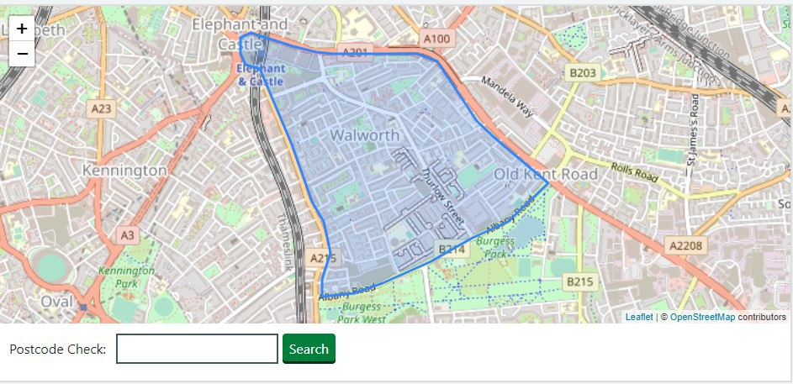

it is your responsibility to inform the surgery any changes with your contact details including your address. If you or/and your family move, you must inform the surgery of your new address and contact numbers and check with us one week later to see if your new address has been accepted. If you do not and your new address is not accepted you will be informed by the Health Authority of your need to be registered with another doctor.

## Urgent Appointments

If you have a clinically urgent issue, please call us before 10.30am and our triage **Clinician** will call you back to ascertain the urgency and advise on the most appropriate next steps. Note you may experience delay with returning your calls.

Serious medical emergencies out of hours – Attend local hospital A&E department

Prescription emergency out of hours; Attend local pharmacists

## Routine Appointments

All registered patients can request an appointment with a GP or a nurse via telephone, in person or online via accuRx or NHS App.

Routine appointments can be made well in advance usually up to four weeks ahead (triage first with a GP).

## Home Visits / Calling the Surgery

Home visits are primarily for housebound patients who are unable to attend the Surgery ie. people who are old and disabled. If home visit is required, please try to phone before 10:30am so that the Doctor can plan their daily routine. The Doctor may speak to you to discuss your request.

3

For results and advice, please telephone between 12;00pm-1:00pm.



**Out of hours.** When our practice is closed you can still get support. You can get expert medical advice and useful information by calling NHS 111 or through 111 online.

The NHS 111 service is available 24 hours a day and can provide patient information, issue prescriptions to a pharmacy of your choice, book a GP appointment, and if necessary, refer people to emergency services.

You can also visit a local pharmacist (chemist) and ask for advice.

In case of a life-threatening emergency, please dial 999 or attend local hospital A&E department.

## Repeat Prescriptions

We encourage our patients to order their repeat prescriptions through the [NHS App](https://www.nhsapp.service.nhs.uk/login) or [accurx](https://accurx.nhs.uk/patient-initiated/g85721). Please ask at reception if you need help registering for our online service. If you cannot order your medication online, please tick the items required on the sheet attached to your last prescription or the slip available from reception then post it to us, hand it in at reception or email us [**souccg.301eaststreetsurgery@nhs.net**](mailto:souccg.301eaststreetsurgery@nhs.net).

We will send your prescription electronically to the pharmacy of your choice for collection.

Repeat prescriptions takes two working days to process and cannot be ordered on the phone.

## Named GP

Dr Arnold Abraham or Dr Christine Furness will be the allocated named GP for registered patients and will be responsible for patients’ overall care at the practice.

The named GP will:

* Take lead responsibility for ensuring that all appropriate services required under the contract with the practice are delivered to you
* Where required, based on the professional judgement of the ‘named’ GP, work with relevant associated health and social care professionals to deliver a multidisciplinary care package that meets your needs.
* Ensure that your physical and psychological needs are recognised and responded to by the relevant clinicians in the practice.

4

* Ensure that patients over 75 years of age have access to a health check if requested, which is already a requirement of the GP contract regulations.
* The Practice will ensure that there is a named accountable GP assigned to each patient.
* New patients will be allocated a GP at the time of registration.
* Your named accountable GP will be the same as your USUAL GP however this does not affect your ability to see any GP of your choice as you currently do.

Please remember that you can still book appointments with any GP of your choice.

# The Clinics and Services

Antenatal clinic. Our local hospitals ask that you self-refer for antenatal care at Guys and St Thomas Hospitals and King’s College Hospital. There is no need to see a GP unless you have a specific concern.

Asthma clinic Baby clinic

Cardiac health promotion Cancer

Cervical cytology screening Child health surveillance (CHS) Chronic Kidney Disease (CKD)

Chronic Obstructive Pulmonary Disease (COPD) Cardio Vascular Disease (CVD

Counselling Diabetes clinic

Family planning clinic GP consultations

Long term conditions monitoring Leg ulcers

Mental Health

NHS Health Checks. For patients over 40 years old. These require you to have some blood tests done and then see the practice nurse to complete the Check Antenatal clinic

Osteopathy - Our osteopath, Mr Munish Bhalla visits the practice on Wednesdays. Appointments with him are made after a referral by one of

5